ICEngineSoft Test Report

Report Date : Wed, Dec 14, 2022 , Time : 1:09:42 AM
Organization : Organisation, Operator : Operator
Data File : 13-12 WCO-LDPE B30.xlsx, Last Modified Date: Wed, Dec 14, 2022,
Config. File : Kirloskar TV1 Engine.xls

Engine Details :

ICEngine set up under test is Kirloskar TV1 having power 5.20 kW @ 1500 rpm which is 1 Cylinder, Four stroke , Constant Speed, Water Cooled, Diesel Engine, with Cylinder Bore 87.50(mm), Stroke Length 110.00(mm), Connecting Rod length 234.00(mm), Compression Ratio 17.50, Swept volume 661.45 (cc)

Combustion Parameters :

Specific Gas Const (kJ/kgK) : 1.00, Air Density (kg/m^3) : 1.17, Adiabatic Index : 1.41, Polytrophic Index : 1.11, Number Of Cycles : 10, Cylinder Pressure Referance : 6, Smoothing 2, TDC Reference :-1

Performance Parameters :

Orifice Diameter (mm) : 20.00, Orifice Coeff. Of Discharge : 0.60, Dynamometer Arm Legnth (mm) : 185, Fuel Pipe dia (mm) : 12.40, Ambient Temp. (Deg C) : 27, Pulses Per revolution : 360, Fuel Type : Diesel, Fuel Density (Kg/m^3) : 839, Calorific Value Of Fuel (kj/kg) : 41150

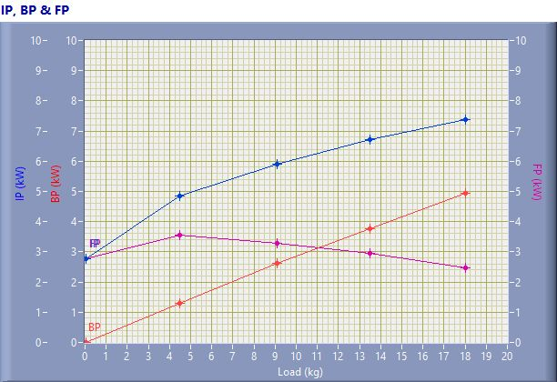

IP, BP & FP

Speed (rpm) | Load (kg) | IP (kW) | BP (kW) | FP (kW)
1587.00 | 0.03 | 2.79 | 0.01 | 2.78
1521.00 | 4.50 | 4.86 | 1.30 | 3.56
1515.00 | 9.08 | 5.91 | 2.62 | 3.29
1470.00 | 13.51 | 6.71 | 3.77 | 2.94
1438.00 | 18.02 | 7.39 | 4.93 | 2.47

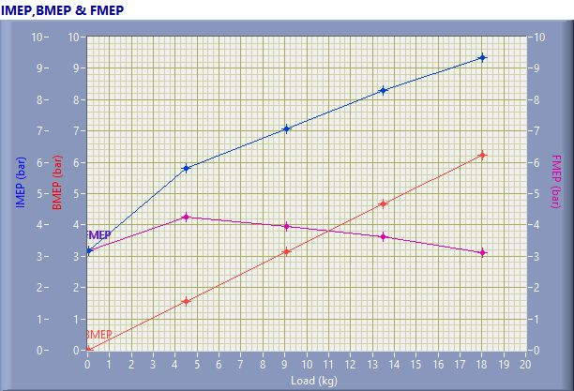

IMEP,BMEP & FMEP

Speed (rpm) | Load (kg) | IMEP (bar) | BMEP (bar) | FMEP (bar)
1587.00 | 0.03 | 3.18 | 0.01 | 3.17
1521.00 | 4.50 | 5.80 | 1.55 | 4.25
1515.00 | 9.08 | 7.07 | 3.13 | 3.94
1470.00 | 13.51 | 8.29 | 4.66 | 3.63
1438.00 | 18.02 | 9.33 | 6.21 | 3.11

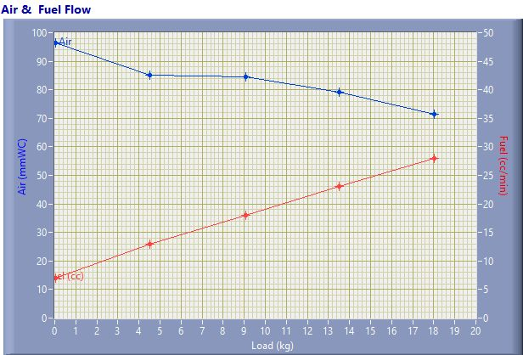

Air & Fuel Flow

Speed (rpm) | Load (kg) | Air (mmWC) | Fuel (cc/min)
1587.00 | 0.03 | 96.55 | 7.00
1521.00 | 4.50 | 85.09 | 13.00
1515.00 | 9.08 | 84.46 | 18.00
1470.00 | 13.51 | 79.26 | 23.00
1438.00 | 18.02 | 71.49 | 28.00

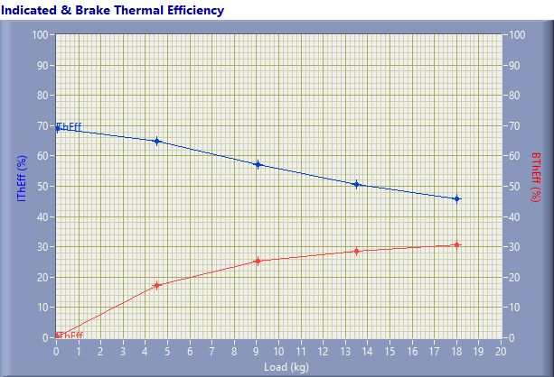

Indicated & Brake Thermal Efficiency

Speed (rpm) | Load (kg) | IThEff (%) | BThEff (%)
1587.00 | 0.03 | 69.16 | 0.24
1521.00 | 4.50 | 65.00 | 17.40
1515.00 | 9.08 | 57.02 | 25.25
1470.00 | 13.51 | 50.74 | 28.51
1438.00 | 18.02 | 45.89 | 30.57

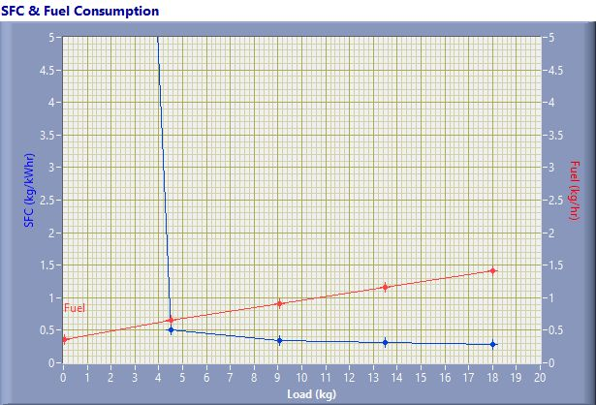

SFC & Fuel Consumption

Speed (rpm) | Load (kg) | SFC (kg/kWh) | Fuel (kg/h)
1587.00 | 0.03 | 36.51 | 0.35
1521.00 | 4.50 | 0.50 | 0.65
1515.00 | 9.08 | 0.35 | 0.91
1470.00 | 13.51 | 0.31 | 1.16
1438.00 | 18.02 | 0.29 | 1.41

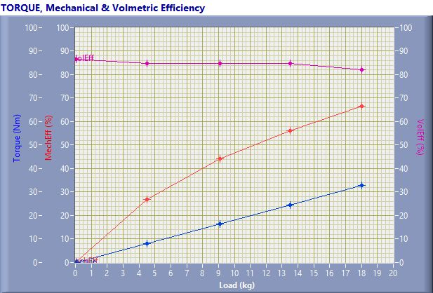

TORQUE, Mechanical & Volmertic Efficiency

Speed (rpm) | Load (Kg) | Torque (Nm) | Mech Eff. (%) | Vol Eff. (%)
1587.00 | 0.03 | 0.06 | 0.35 | 86.56
1521.00 | 4.50 | 8.17 | 26.76 | 84.79
1515.00 | 9.08 | 16.49 | 44.28 | 84.81
1470.00 | 13.51 | 24.51 | 56.19 | 84.67
1438.00 | 18.02 | 32.71 | 66.62 | 82.20

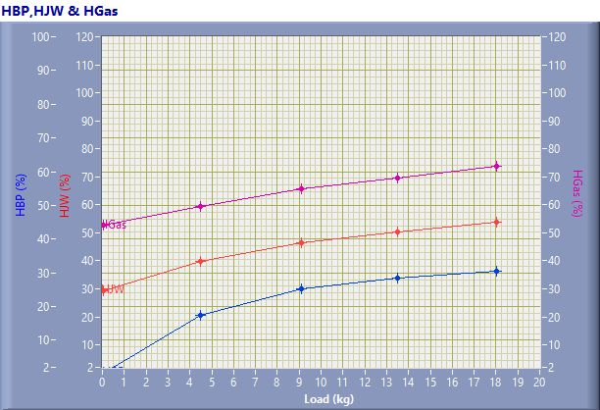

HBP,HJW & HGas

Speed (rpm) | Load (kg) | HBP (%) | HJW (%) | HGas (%) | HRad (%)
1587.00 | 0.03 | 0.24 | 29.11 | 23.31 | 47.34
1521.00 | 4.50 | 17.40 | 22.40 | 19.53 | 40.67
1515.00 | 9.08 | 25.25 | 21.31 | 19.23 | 34.21
1470.00 | 13.51 | 28.51 | 21.93 | 18.98 | 30.58
1438.00 | 18.02 | 30.57 | 23.22 | 20.10 | 26.12

Observation Data

Speed (rpm) | Load (kg) | Comp Ratio | T1 (deg C) | T2 (deg C) | T3 (deg C) | T4 (deg C) | T5 (deg C) | T6 (deg C)
1587 | 0.03 | 17.50 | 39.18 | 45.88 | 39.18 | 38.82 | 121.99 | 99.58
1521 | 4.50 | 17.50 | 39.17 | 48.75 | 39.17 | 39.75 | 182.74 | 137.90
1515 | 9.08 | 17.50 | 39.22 | 51.84 | 39.23 | 41.58 | 238.38 | 176.61
1470 | 13.51 | 17.50 | 39.27 | 55.85 | 39.27 | 44.23 | 299.67 | 220.68
1438 | 18.02 | 17.50 | 39.33 | 60.70 | 39.34 | 47.27 | 393.08 | 276.90

Observation Data

Air (mmWC) | Fuel (cc/min) | WaterFlow Engine (lph) | WaterFlow Cal (lph)
96.55 | 7.00 | 150 | 75
85.09 | 13.00 | 150 | 75
84.46 | 18.00 | 150 | 75
79.26 | 23.00 | 150 | 75
71.49 | 28.00 | 150 | 75

Result Data

Torque (Nm) | BP (kW) | FP (kW) | IP (kW) | BMEP (bar) | IMEP (bar) | BTHE (%) | ITHE (%) | Mech Eff. (%)
0.06 | 0.01 | 2.78 | 2.79 | 0.01 | 3.18 | 0.24 | 69.16 | 0.35
8.17 | 1.30 | 3.56 | 4.86 | 1.55 | 5.80 | 17.40 | 65.00 | 26.76
16.49 | 2.62 | 3.29 | 5.91 | 3.13 | 7.07 | 25.25 | 57.02 | 44.28
24.51 | 3.77 | 2.94 | 6.71 | 4.66 | 8.29 | 28.51 | 50.74 | 56.19
32.71 | 4.93 | 2.47 | 7.39 | 6.21 | 9.33 | 30.57 | 45.89 | 66.62

Result Data

Air Flow (kg/h) | Fuel Flow (kg/h) | SFC (kg/kWh) | Vol Eff. (%) | A/F Ratio | HBP (%) | HJW (%) | HGas (%) | HRad (%)
32.00 | 0.35 | 36.51 | 86.56 | 90.81 | 0.24 | 29.11 | 23.31 | 47.34
30.04 | 0.65 | 0.50 | 84.79 | 45.90 | 17.40 | 22.40 | 19.53 | 40.67
29.93 | 0.91 | 0.35 | 84.81 | 33.03 | 25.25 | 21.31 | 19.23 | 34.21
28.99 | 1.16 | 0.31 | 84.67 | 25.04 | 28.51 | 21.93 | 18.98 | 30.58
27.53 | 1.41 | 0.29 | 82.20 | 19.53 | 30.57 | 23.22 | 20.10 | 26.12

